Proposed 3DLE Feature Set and Signal Flow V1.1
ASI Audio – SDJ – July 7, 2021

Contents:

- Block Diagram Description
  - Ambience (Concha) Mic input
  - BT (Phone) Audio
  - Limiter
  - Graphic EQ
  - CROS
  - dBCheck
  - Frequency Response
- Appendix 1: Target Frequency Responses
- Appendix 2: Limiter
  - Limiter Overview
  - Limiter Details
  - Clipping Protection Limiting
  - Limiter Action Linking
- Appendix 3: dBCheck
- Appendix 3a: A-Weighting

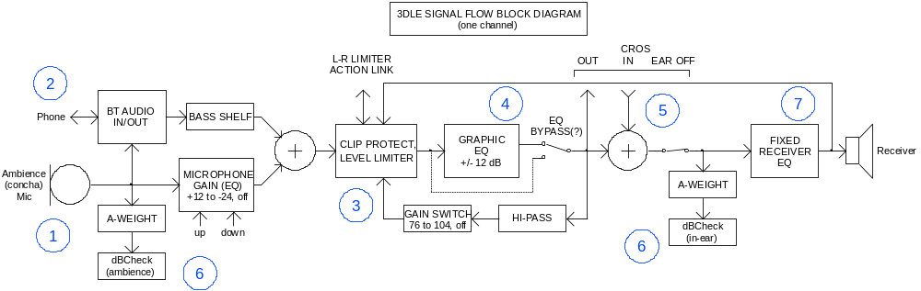

Block Diagram Description:

Referring to the signal flow block diagram (showing just one of the left or right channels, except for the optional single Mouth Mic):

- Ambience (Concha) Mic Input: The full frequency response, wide dynamic range earpiece microphone should have a noise floor no higher than 26 dBA-SPL and an overload of at least 126 dBA-SPL, as input to the processor. Its signal is gain adjusted by the app in mostly 2 dB steps from +12 dB down to -24 dB and off (same steps as the 3DME). This stepping should also be controllable by up/down pushbuttons accessible to the user when the app is disconnected. The 0 dB setting represents 0 dB insertion gain through the system, where the ambience heard by the user is the same as they would experience without the system in their ears (see Appendix 1). The microphone will likely not need any significant EQ, other than perhaps a bit of high frequency rolloff to compensate for the high frequency resonant peaking of typical MEMS microphones.

- BT (Phone) Audio: The BT audio interface block accepts stereo and phone call audio from the phone and also sends the phone audio from the summed ambience mics for phone communication. The level of the BT audio is controlled here (?), in the app (?), or both (?). The stereo BT Audio undergoes a modest shelving bass boost (Appendix 1, dotted green curve) to modestly emphasize the bass in comparison to the ambience (to compensate for the loss of body feel when not immersed in the sound field).

- Limiter: The gain-adjusted earpiece microphone signal and any incoming BT audio mix together, with the combined signal then feeding the limiter stage, which acts on the combined signal. (The limiter stage and the graphic EQ stage can be reversed in order, assuming effectively unlimited digital signal dynamic range, as long as the limiter sense points remain unchanged.) This stage limits the short-term-averaged, very roughly A-weighted level at the user’s ear to the level set by the app. The stage also prevents sustained output clipping through fast-response sensing of the output drive level, irrespective of the app’s limiter threshold setting. An interconnection is shown for Left-Right Limiter Action Linking. The behavior of the limiter is described in detail in Appendix 2.

- Graphic EQ: The dynamic range-controlled signal leaving the limiter stage passes to the graphic equalizer (or in reverse order). The diagram shows a bypass switch for when the equalizer is not needed or wanted, but this would only be relevant if there is some benefit to bypassing, such as reduced latency, or if this is felt to be a useful user option, for quick comparison.

- CROS: The following CROS (contralateral routing of signal) stage allows the microphone signal from a user’s weak ear to feed their stronger ear. The following “ear off” switch can remove all sound from the bad ear, for situations such as Meniere’s disease, where residual sound in the ear would result in unwanted distortion.

- dBCheck: The input to the dBCheck functions are tapped off the pre-level adjustment microphone signal for the ambience portion and just before the receiver drive/EQ for the in-ear portion. The signal at this latter point should accurately represent the equivalent audio level and frequency response of a sound coming from outside an open ear that the user will now experience in their sealed ear, irrespective of the fixed receiver drive gain and EQ needed by the receiver to achieve the target frequency response and level. The dBCheck functionality is described in detail in Appendix 3.

- Frequency Response: Before finally driving the receiver, the signal undergoes fixed response equalization to provide the proper level and to compensate for and enhance the receiver characteristics so as to match the desired electroacoustic response as closely as possible (see Appendix A).

Appendix 1: Target Frequency Responses

The responses are measured in a Zwislocki coupler or simulated Zwislocki coupler. The target ambience response shown should be the coupler response vs. the acoustic source measured immediately in front of the earpiece microphone. For the BT Audio response, the source is the electrically coupled BT audio input at an appropriate matching level. The BT response is boosted ~5 dB in the lower frequencies over the ambience response to compensate for the lack of body effect bass support when the user is not immersed in the acoustic field, and because people like it.
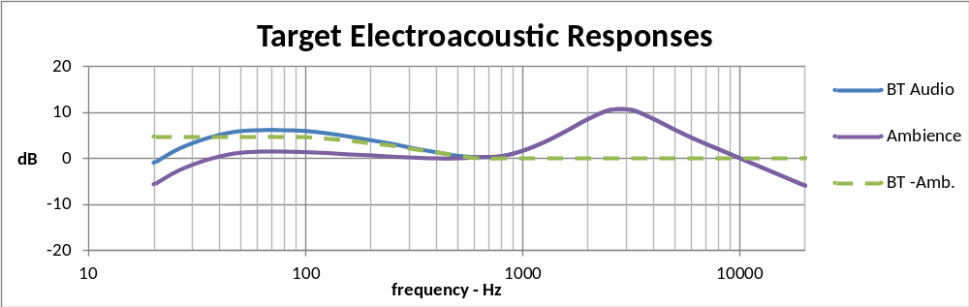
It is expected that the ambience response curve will be obtained by the combination of the receiver’s in situ response and the final fixed receiver EQ, such that the signal just prior to this final EQ will properly represent the level and response of an equivalent acoustic signal as measured outside the ear. The shelving bass boost shown should be applied to the incoming BT audio signal prior to mixing with the level-adjusted earpiece microphone signal to achieve the BT Audio response. To note, it is acknowledged that there will be some deviations from these ideal curves, especially at the frequency extremes.

Appendix 2: Limiter

Limiter Overview:
The limiter is a feedback type, where an increasing measurement of the output signal level feeds back to reduce the preceding gain. The output signal sensing is at a point where the signal accurately represents the outside-the-ear equivalent of the sound feeding the occluded ear, which is the reference for hearing safety standards.

The graph below shows the measured 1 kHz, steady state level limiter transfer function of the present 3DME analog limiter. The 3 dB threshold steps shown, from 84 to105 dB-SPL, are changing to 4 dB steps from 76 to 104 dB-SPL in the next 3DME version, which should be matched in the 3DLE. The limiter shows a maximum gain reduction of 18 dB, which is an inconsequential limitation of the analog circuitry and does not need to be replicated in a digital implementation. (The maximum gain reduction could be higher, if more convenient.) The dotted “off” line shows no limiting until a high maximum level that should be just prior to output clipping, where the level is limited by the secondary clipping protection function. The steady state limiting action shows a 5:1 compression slope through the central limiting region, which is determined by the overall feedback loop gain during limiting.

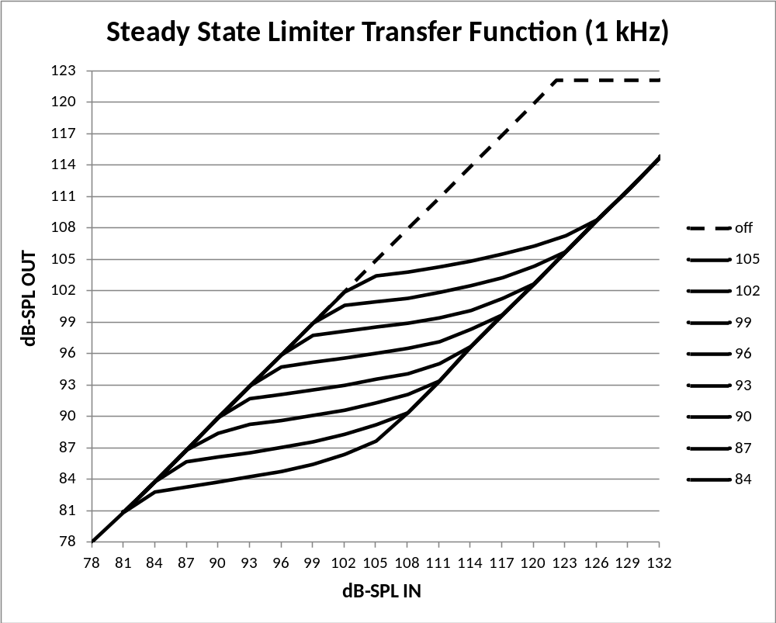

Limiter Details:
The frequency response filtering for the needed level-sensing consists primarily of just a single 1st order roll-off below 738 Hz, shown in the block diagram as “HI-PASS”. This filtering very roughly approximates A-weighting, and also reduces the tendency of strong bass pulsations to result in annoying pumping of mid-band frequencies. The filter is followed by 4 dB-stepped gain settings that establish the various limiter SPL thresholds. The limiting signal levels at the output of this stepped gain stage can then be fixed, for the benefit of the following limiting functionality.

In the analog implementation, this normalized signal level is half-wave rectified as the first step towards level measurement, but it may be as convenient here to implement full-wave rectification. The rectified signal is log-converted and filtered to establish the limiting-determining level representation. To achieve the 5:1 compression slope, the gain reduction in the limiting regions is in a 4:1 decibel ratio with the measured level; e.g., a 1 dB increase in the measured level results in a 4 dB gain reduction. To implement the feedback topology, the gain reduction occurs before the level measurement, as indicated in the block diagram.

In addition to the steady-state characteristics, the level measurement needs defined attack and release characteristics. The decay characteristic, elicited when the instantaneous log-rectified level drops below the instantaneous level measurement, is a dB-linear 25 dB/Sec, equivalent to an exponential decay R-C time constant of 350 mSec in the non-dB world. The attack characteristic, elicited when the instantaneous log-rectified level increases above the instantaneous level measurement is inversely proportional the exponent of that dB difference (the original non-dB level ratio). Examples: for very small differences, the attack and decay times are equal at 25 dB/Sec (simple averaging); for a 10 dB difference of the instantaneous level measurement over the instantaneous level measurement, the attack is at 3.16 x 25 dB, or 79 dB/Sec; for a 20 dB difference, the attack is at 250 dB/Sec; for a 30 dB difference, the attack is at 790 dB/Sec, which is probably fast enough.

As can be seen in the Limiting Transfer Function graph above, the nominal limiting threshold is in the central area of the limiting region, with the initial threshold a couple of dB below that nominal level. The level measurement needs to have a resting level that is not more than a few dB below this initial threshold level, to minimize the response delay to loud sounds following quiet spells.

Clipping Protection Limiting:
In addition to the primary level-limiting function, the limiter action also includes a clipping protection function. The final output waveform driving the receiver is sensed to detect when it reaches within perhaps 2 or 3 dB of clipping. At that point, the limiting-determining level measurement discussed above is pulled upwards with a rapid attack time of about 1,000 dB/Sec (1 dB/mSec) until the onset of clipping is no longer sensed. (The analog implementation also senses internal circuit points for potential clipping, but it is assumed that the digital signal representations have sufficient dynamic range to obviate that concern.)

Limiter Action Linking:
This discussion has so far been referring to one channel in isolation. In most instances, it will be desirable for any limiting action to occur identically in both left and right ears, irrespective of which ear’s microphone may be receiving the most excessive level. This is accomplished by linking the gain reduction signals of the channels such that the gain reduction in both channels is the amount determined by the channel with the greatest calculated gain reduction. This is called L/R Limiter Action Linking. The app provides the option to “Unlink” the limiter action for special circumstances.

Appendix 3: dBCheck

The dBCheck function simultaneously and independently monitors the electrical signal representing the outside-the-open-ear equivalent of the sound feeding the occluded ear (achieved by the designated tap-off point location) and the actual outside sound taken from the Ambience Mic. It does this for both ears, resulting in four independent, identical processing streams. The presentation to the user may show all four, or may take the worst case of the two ears for each of the electrical and acoustic feeds, for a simplified presentation.

The first step for each of these signal streams is to A-weight them, as shown for reference in Appendix 3a. The 1 kHz equivalent level is the reference for the following calculations.

Both the NIOSH and the less-conservative OSHA scales are based on the maximum “safe” average power over an extended period of time, as represented by the dBA-SPL level of that average power (NOT the average of the dB levels). The chart shows the “acceptable” dB levels for sample time intervals. Note that the NIOSH “exchange rate” – the level difference for a doubling or halving of safe operation – is 3 dB, while for OSHA, it’s 5 dB. These rates allow for extending the chart to longer and shorter time periods than those shown.
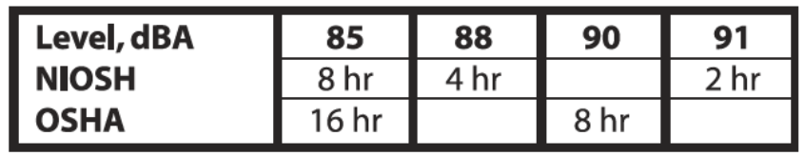

Since all the results are based power averages, the first step is to take the signal sample and square it. (The linear representation of the signal has no further use.) The string of squared values can be averaged over e.g. 1 second intervals to reduce the data pile-up, as that will be an adequate refresh rate for any near-instantaneous dB level display. Beyond that, these 1 second averages may be further averaged over, say, 1 minute intervals (or possibly longer) for longer term storage, for later app readout, so that the user can go back and see what they experienced without having to monitor in real time.

The greater use for these medium-term averages is to form a cumulative average over a more extended time period, for NIOSH and OSHA safety calculations/predictions. This time period, set through the app, could be ongoing forward-looking from the time of setting, or a backwards retrospective, say for the last hour or more. Either way, the basis for the calculation is the average power over the designated time period. The calculations below produce the safe minutes, but the display should probably show hours and minutes.

The following example calculations are for demonstration and are based on a digital representation where a full-scale sine wave represents 130.58 dB-SPL. (This is the level determined by the hardware of the dedicated dBCheck product in development.) The constants for the 3DLE will be different, dependent on its specific signal scaling.

Example Formulas:

Cumulative average power (applicable to short term and total averages):

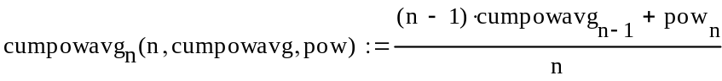

where: cumpowavg_{n} is the updated cumulative power average
cumpowavg_{n-1} is the previous cumulative average since the start of the interval
pow_{n} is the new power reading of sample n
n is the total number of power readings taken since the start of the interval

Power count to dBA, based on F.S. = ±2¹⁵ counts (16-bit), or ±2²³counts (24-bit):

dBA = 10*log₁₀(powavg) + 43.27 (16-bit)
10*log₁₀(powavg) - 4.89 (24-bit)

where: powavg is a mean square level

Round any display to the nearest whole dB

Safe minutes, based on F.S. = ±2¹⁵ counts (16-bit), or ±2²³counts (24-bit):

NIOSH(cumpowavg) = 7,386,200/(cumpowavg^1.00343) (16-bit)
502,830,398,930/(cumpowavg^1.00343) (24-bit)

OSHA(cumpowavg) = 312,312/(cumpowavg^0.60206) (16-bit)
247,970,022/(cumpowavg^0.60206) (24-bit)

where: cumpowavg is the total cumulative power average over the designated sampling interval

Appendix 3a: A-Weighting

A-weighting of the signal as heard by the ear is needed for level-sensing for the dBCheck function, as this is the basis of the OSHA and NIOSH safety ratings. A very rough approximation to this characteristic is also used for level-sensing for the limiter function (a single 1st order high-pass at ~ 738 Hz).
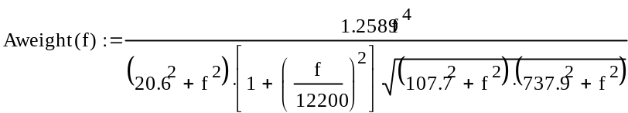

Corner frequencies:

Low frequency: High frequency:
1st order: 107.7 Hz, 737.9 Hz 2nd order: (2x 1st order): 12.2 kHz
2nd order (2x 1st order): 20.6 Hz

